Indirect collegial supervision based on preselected topic about teaching, student supervision, etc.
The focus person/assistant professor is looking for supervision regarding a problem/challenge in teaching, or considerations related to new initiatives in teaching, student supervision, exams, or a new course, etc.
Whatever the topic of interest, start by establishing the purpose of the supervision together with the supervisor, and consider what you would like to achieve in the supervision session.
Time: …  [Total time for the supervision meeting is about 45-60 mins] | Topic or issue: …
Structure and planning
- Preparation: What is the topic/ focus area for supervision? | The focus person, e.g. the assistant professor, sends a brief description to the supervisor regarding the focus area for the supervision, and what he/ she might be in need of in that respect.
- Setting the scene | Initiate the meeting by checking common ground for the supervision, e.g., if there are any amendments to the supervision topic.  Finally, agree on the process (see this description) and the time frame.  Make sure there is time to reflect on the process and future steps.
- The supervision dialogue | The supervisor now initiates the conversation by asking clarifying and reflexive questions to deepen the learning process.  This is preferably done using a questioning technique such as “The questioning circle” (see below), the bearing principle being to go through certain stages so that the supervisor carefully familiarizes him-/herself with the ideas, reasons and evaluations of the focus person, before attempting to contribute own views and advice.
- Concluding the supervision and next steps | Conclude by asking the focus person to summarize his/her experience of the collegial supervision session including learning points, reflection on the supervision sessions and focus for future development.  The supervisor shares his/her thoughts about the supervision session.  The session is concluded by specifying any further agreements or perhaps finishing closing the supervision process.

Active listening and reflexive questioning – The Questioning Circle
Carrying out a qualified dialogue requires listening and questioning skills, such as distinguishing between open and closed questions. Open questions are useful for expanding the supervisee’s own ideas and new options, also associated with deep learning. Closed questions expose already known answers and information, eliciting surface learning. It is important to consciously employ different kinds of questions, with an emphasis on open questions, which promote the developmental potential in the supervisee. We recommend the well-established conversation model for supervision, “The questioning circle”, inspired by Karl Tomm’s four question types. (Wichmann et al. 2002).

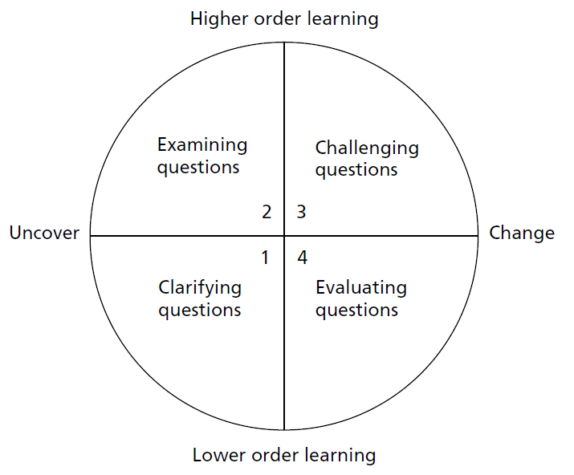
The Questioning Circle distinguishes between the two ends of the horizontal dimension, whether the intention is asking questions to expose and understand what the focus person understands; or asking questions to increase and thus change or transform the focus person’s current understanding.
Similarly, the two poles on the vertical dimension show the supervisor’s intention to ask questions to either clarify existing knowledge and circumstances for action, which make for lower-order learning; or to expand and inform the basis of action by reflexive questioning into the realms of higher-order learning, i.e. examining reasons and assumptions linked to the situation and exploring actionable alternatives.

The intersection of the two axes depicts four phases with corresponding four types of questions. The model is used to guide the conversation through various stages, to promote learning and competence development. It is not a fixed model but follows a certain progression through the four phases: starting with phase 1. clarifying questions; then examining questions for understanding, in phase 2.; expanding into challenging explorations in phase 3.; in phase 4., the supervisor elicits concluding insights and commitments to action. The conversation may well return to one of the previous phases, but it should not jump towards the conclusion without having passed through all stages.
- Clarifying questions  Asks facts about knowledge: | - What is your understanding of the problem/situation?  - What are you trying to achieve?  - What is the difference between how things are now and how you would like them to be?  - How long have you experienced this situation?  - When did the situation (first) arise?  - Who else is involved?
- Examining questions  Ask for reasons and rationales: | - What is challenging for you about this issue?  - What is important, what is urgent, what is the priority?  - How do you think the students see the situation?  - What are your considerations about …?  - What makes it hard for you to …?
- Challenging questions  ask for new perspectives, options and possibilities | - What would be the best outcome in the situation?  - What options do you see open to you?  - What do you think your best colleague would do?  - What suggestions do you have for a different approach?  - What are the effects of this on [others]?
- Evaluating questions  Ask for choices, decisions, and conclusions | - Based on this conversation, what do you conclude?  - It sounds like you could solve your problem by doing X. Is this correctly understood?  - So how do you think this can be solved?  - What are your next steps?

